Development Report

Hero class
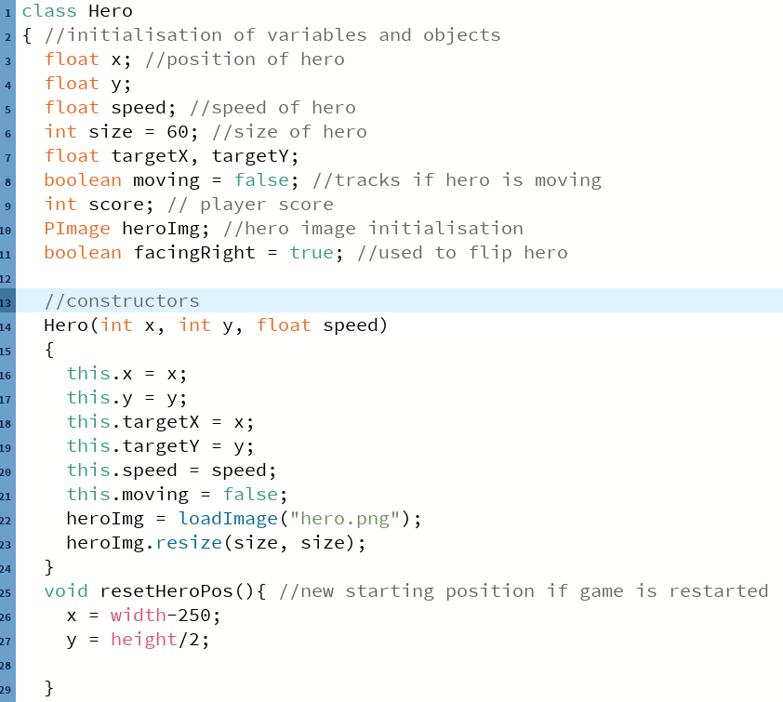
The development was started with the hero (player) development. These are the variables, images and constructor used.

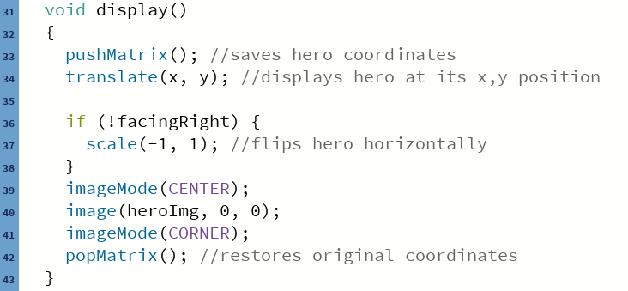
This piece of code ensures that when the hero is moving left, is faces left and when its moving right, it faces right, it does this by flipping the hero image with the scale procedure to flip the hero horizontally. The facingRight Boolean variable tracks which way the hero is facing.

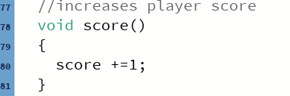
This procedure is used in the main body, it’s used to increment the score by 1 each time the hero touches enemyA.
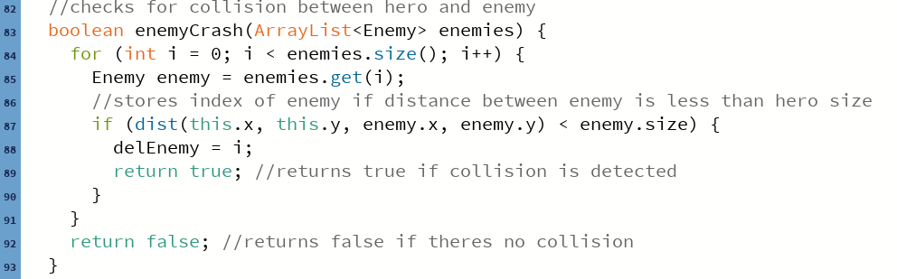
This function returns true if collision is detected between the hero and enemy and false otherwise. Firstly, it uses a for loop to loop through all the enemies in the array list and ‘i’ as the index to track the enemies. It then uses an if command to check if the hero and enemy have collided by calculating the distance between them. Then it returns true or false based on this.

Abstract Enemy Class
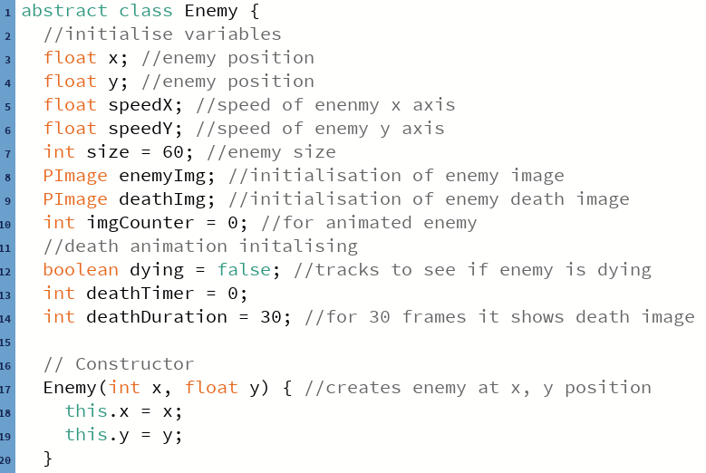
The abstract enemy class was created next, starting by initialising all the variables and images needed along with the constructor.

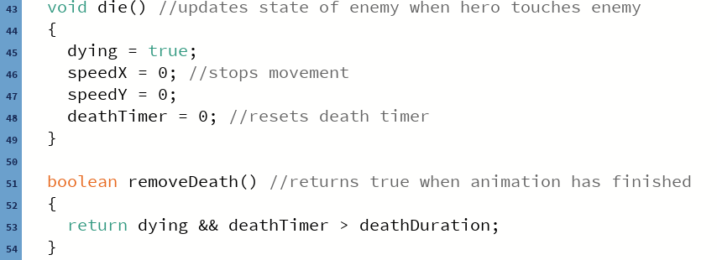
The die procedure is called to stop the enemy movement when it collides with the hero. The removeDeath function returns true when the enemy death animation has finished, it is called before the enemy is removed from the screen to allow the program to understand when the animation has finished.

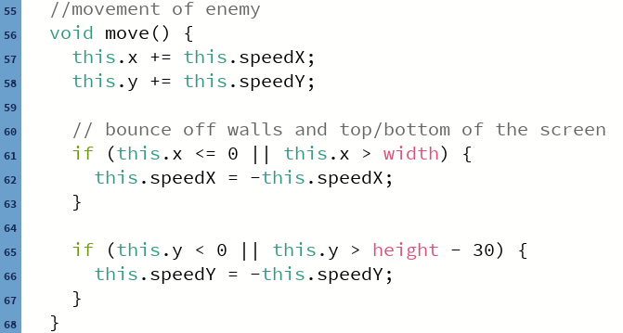
This method allows the enemy to move towards the castle.

Enemy A Class
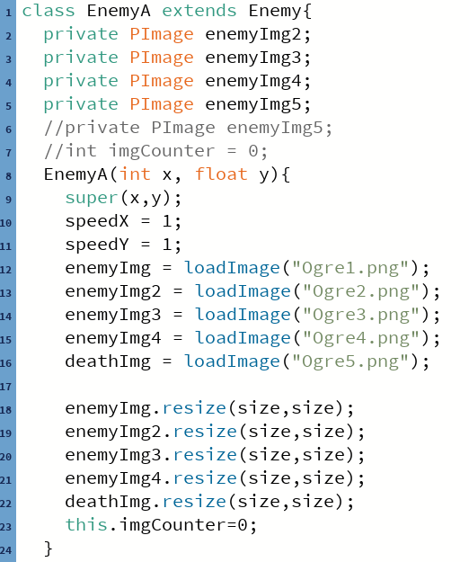
EnemyA inherits methods and methods from the abstract enemy class, more images were added to the class for animation, they are private so they can only be used in this class. SpeedX, Y controls the speed of enemy A. The ‘super’ command calls the constructor from the parent enemy class.

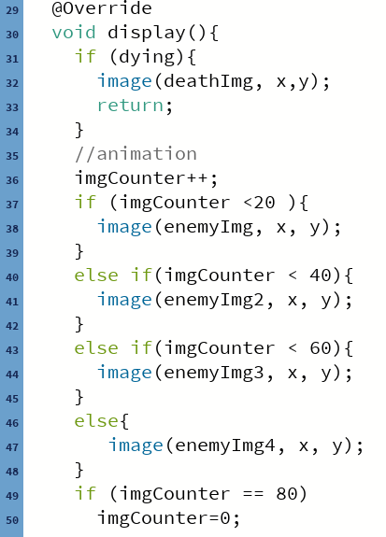
The ‘@override’ replaces the display method in the parent enemy class, this is an example of polymorphism because it behaves differently based on the type of enemy. If the enemy state is in contact with the hero (dying = true) then it will show the enemy death image.
The animation section method uses a variable that increments each frame (imgCounter) to keep each enemy image on screen for 20 frames before switching to the next image, when the variable has reached 80, it resets back to 0 and starts again from image one.

Main Body
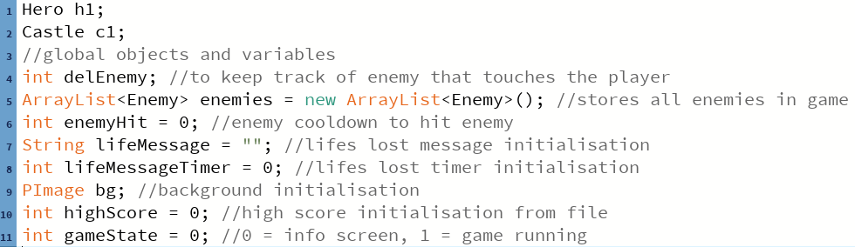
The main body class first initialises all the variables it will need throughout this main class. The enemy array list is also initialised; this stores all the enemies in the game.

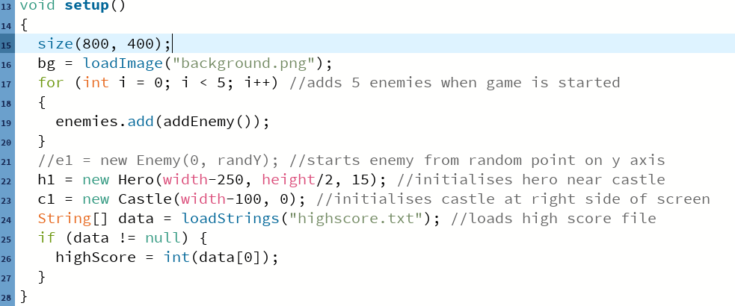
In the setup procedure, the size of the game window and background image is initialised. In the for loop, five enemies are added when the game is started, the position of the hero and castle is also initialised. The high score array loads the high score file and reads the stored integer of the high score. If the file exists, the first line of the high score is read.

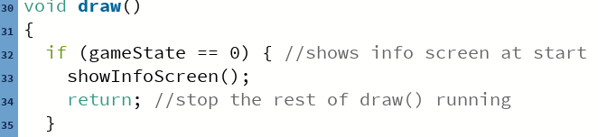
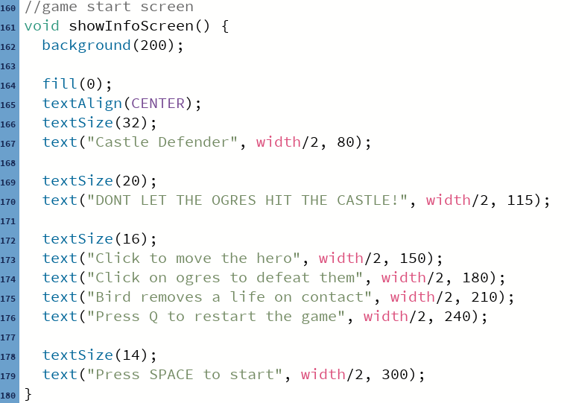
The game starts with an information screen, gameState changes when the user has read the information.

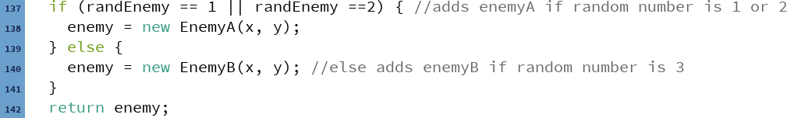
Uses random number 1 - 3 to output enemyA/B, if the random number is 1 or 2, it will add new enemyA, else it will add new enemyB .

Castle Class
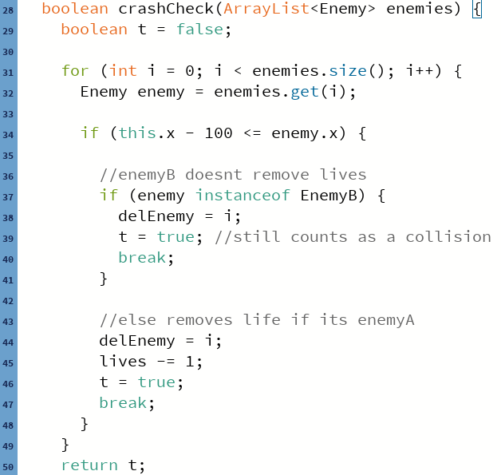
This function is used to detect if the enemy is in contact with the castle. It first checks it’s in contact with the castle then stores the index, if it is, then it checks if its enemyB, then it removes the enemy from the screen, else (enemyA), it does the same but it removes a life too.

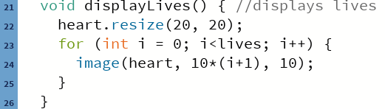
This is the method to initialise the player lives (hearts) in an organised manner apart.

Word document exactly 600 words minus titles and this comment.

